Retail Sales Data Processing and Business Insights Generation

1. Project Overview
ABC Retail Solutions receives retail transaction data from multiple operational systems. Since the data originates from different sources, it contains several quality issues such as missing values, inconsistent records, and sensitive customer information. These issues make it difficult to generate accurate reports and business insights.
The objective of this project was to build a complete data processing pipeline that combines transaction data from multiple sources, performs data cleaning and validation, protects customer information, and prepares a curated dataset for reporting purposes. The final dataset was connected to Power BI to create an interactive dashboard for analyzing revenue trends, category performance, product performance, and regional sales distribution.
The implementation was carried out using Python for data processing and Power BI for visualization and reporting.
2. Problem Statement
ABC Retail Solutions operates through multiple sales channels and stores located in different cities. Transaction data is collected from different systems and stored in separate files. Due to differences in data entry and source systems, the datasets contain missing values, inconsistent records, and customer information that requires protection.
The organization requires a standardized data processing solution that can:
- Combine data from multiple transaction sources.
- Validate and clean the collected data.
- Handle missing values and invalid records.
- Protect personally identifiable information.
- Generate business-ready datasets.
- Support reporting and decision-making through dashboards and KPIs.

The solution should provide reliable business metrics such as revenue, customer count, transaction count, category performance, product performance, and city-wise revenue analysis.
3. Dataset Description

3.1 Product Details Dataset
The product master dataset contains standardized information about products.
Columns:
- product_id
- product_name
- category
- price
This dataset was used as a reference table to validate and enrich transaction records.

3.2 Retail Data 1
The first transaction dataset contains customer purchases collected from one source system
Major fields include:
- transaction_id
- customer_id
- customer_name
- product_id
- product_name
- category
- purchase_location
- city
- transaction_date
- quantity
- payment_method
- discount
- email
- phone
- payment_status

3.3 Retail Data 2
The second transaction dataset contains transaction records from another source system and follows a structure similar to Retail Data 1.
Both retail datasets were combined to create a single unified transaction dataset for processing and reporting.
4. Architecture Diagram

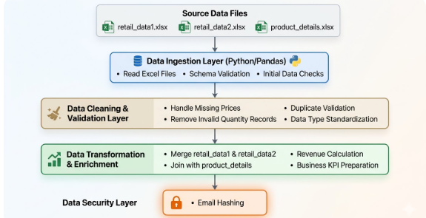

5. Data Flow Diagram
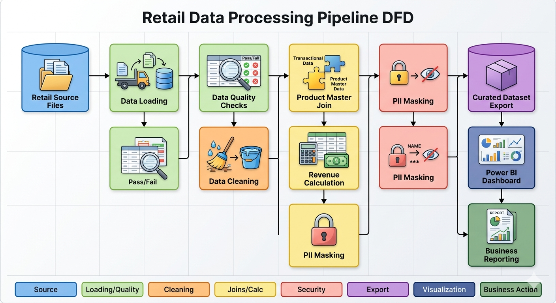

6. Data Cleaning Strategy
Data cleaning was an important stage of the project because the transaction data was collected from multiple source systems. Before performing any analysis, the datasets were carefully examined to identify and correct data quality issues that could affect reporting accuracy and business insights.

6.1 Missing Value Handling
During data profiling, it was observed that some transaction records contained missing values in the price column. Since price is required for revenue calculation, these missing values had to be addressed before further processing.
To resolve this issue, the product master dataset (product_details.xlsx) was used as a reference source. Each transaction record was matched with the corresponding product using the product_id field. The standard product price from the product reference table was then used to populate the missing price values.
This approach ensured consistency in pricing information across all transaction records and allowed accurate revenue calculation. Using the product master dataset also reduced the risk of introducing incorrect values during the cleaning process.

6.2 Duplicate Validation
After combining the two retail transaction datasets into a single dataset, duplicate validation was performed to identify repeated records. Duplicate transactions can lead to inflated revenue figures, incorrect customer counts, and misleading business metrics.
The combined dataset was checked for duplicate transaction entries using transaction-level attributes. Any identified duplicate records were removed to ensure that each transaction was represented only once in the curated dataset.
Performing this validation step helped maintain the accuracy and reliability of all subsequent calculations and reports.

6.3 Invalid Quantity Handling
The quantity field represents the number of units purchased in a transaction. Since a sales transaction cannot logically have a quantity of zero or a negative value, the dataset was examined for invalid quantity entries.
Records containing invalid quantity values were identified and excluded from further processing. Removing these records ensured that revenue calculations and product performance analysis reflected only valid sales transactions.
This validation step improved the overall quality of the dataset and prevented inaccurate reporting results.

6.4 Data Standardization
Because the data originated from multiple source files, standardization was necessary to create a consistent structure for analysis and reporting.
The following standardization activities were carried out:
- Column names were converted into a consistent naming format.
- Data types were validated and converted where necessary.
- Product information was verified using the product master dataset.
- Numeric fields such as price, quantity, discount, and revenue were converted into appropriate numerical formats.
- Consistent formatting was maintained across all transaction records.
Standardization improved data consistency and simplified downstream processing and reporting activities.

6.5 Data Quality Verification
Once cleaning activities were completed, the dataset was re-evaluated to ensure that identified issues had been resolved successfully. Validation checks were performed to confirm that:
- Missing prices were populated correctly.
- Invalid quantity records were removed.
- Duplicate transactions were eliminated.
- Product information matched the reference dataset.
- Required fields were available for reporting and analysis.
These verification steps ensured that the final dataset was suitable for generating reliable business insights.
7. Transformation Logic
After completing the data cleaning process, a series of transformations were performed to prepare the data for business intelligence reporting and dashboard development.
The objective of the transformation stage was to convert raw transaction data into a structured, analytics-ready dataset capable of supporting KPI calculations, trend analysis, and interactive reporting.
7.1 Dataset Consolidation
The project involved two separate retail transaction datasets collected from different source systems. Since business reporting requires a unified view of transactions, both datasets were combined into a single consolidated dataset.
Combining the datasets created a centralized transaction repository and eliminated the need to analyze multiple files separately. This also simplified reporting and ensured that all business metrics were calculated from a single source of truth.
7.2 Product Data Enrichment
To improve data quality and consistency, the consolidated transaction dataset was enriched using the product reference dataset.
The product_details table was joined with the transaction dataset using product_id as the common key. This process helped validate product-related information and provided standardized product details wherever required.
The enrichment process ensured that product names, categories, and pricing information remained consistent throughout the dataset.

7.3 Revenue Calculation
Revenue was calculated at the transaction level after all required fields had been validated. The calculation considered the standard product price, quantity purchased, and any applied discount field values. The calculation logic was implemented uniformly across all records using the formula:
\(\text{Line\ Revenue}=(\text{Price}\times \text{Quantity})\times (1-\text{Discount})\)
This calculated field serves as the foundation for all high-level financial reporting, regional performance metrics, and product ranking matrices displayed on the final executive dashboard.

7.4 Data Security & Masking
To comply with data privacy regulations and protect customer confidentiality, a Data Security Layer was implemented before data export. Sensitive Personally Identifiable Information (PII) fields were secured as follows:
- Email Hashing: SHA-256 cryptographic hashing was applied to user email addresses, converting plain text into unique, irreversible alphanumeric strings. This allows for customer retention tracking without exposing individual identities.
- Name Masking: Customer names were partially masked (e.g., changing John Doe to J*** D***) to safeguard personal details on granular data tables while keeping the datasets usable for internal processing layers.

7.5 Curated Dataset Export
The final transformed, enriched, and anonymized data was exported as a unified, optimized schema (curated_sales_data.csv). This file serves as the clean "single source of truth," stripping away operational pipeline complexities and providing an analytics-ready structure directly optimized for Power BI import.
8. Power BI Dashboard Realization & KPI Analysis
The curated dataset was connected to Power BI to construct the Retail Database Analysis Dashboard. The interface utilizes slicers and interactive visual objects to provide an immediate pulse on operational metrics:
8.1 Executive High-Level KPIs
The summary cards on the right side of the dashboard display consolidated enterprise metrics at a glance:
- Total Revenue (1.16bn): The total net revenue generated across all operational branches.
- Total Transactions (8K): Total volume of successfully cleaned and processed checkout records.
- Total Customers (2K): Unique customer count determined via hashed identifier metrics.
- Average Order Value (147.08K): The baseline spend rate per transaction, used to monitor buyer behavioral shifts.

8.2 Regional & Categorical Performance
- Revenue by City: A horizontal bar chart reveals localized market trends. Chennai leads as the highest revenue-generating city, followed closely by Delhi and Hyderabad, while Bangalore tracks as the lowest of the major hubs.
- Revenue by Category: Visual comparison shows Electronics dominating gross revenue distribution, significantly outperforming Furniture, Home Appliances, and Clothing.
- Revenue by Payment Method: A distribution pie chart indicates a highly balanced payment landscape. Card payments capture the top share (302.32M / 25.97%), while NetBanking, UPI, and Cash share almost equal quadrants, roughly hovering around 25% each.

8.3 Product Performance Analysis
- Top 10 Products (Volume & Value): Represented via a localized bar chart and a corresponding category pie distribution chart. The Laptop line remains the premier business driver, commanding an overwhelming 40.06% (466.25M) of top product revenue. Sofa systems take the second position (150.71M / 12.95%), followed sequentially by Phones and Refrigerators, while Shoes and Shirts track at the bottom of the top tier.

11. Conclusion
The objective of this project was to develop a reliable data processing solution for retail transaction data and transform raw operational records into meaningful business information. By integrating data from multiple sources, performing data quality checks, handling inconsistencies, and protecting sensitive customer information, a structured and analytics-ready dataset was successfully created.
The implementation provided a standardized approach for processing retail data, ensuring that business reports are generated from consistent and validated information. The resulting dataset enabled the calculation of key performance indicators and supported detailed analysis of sales performance across products, categories, cities, and payment methods.
The Power BI dashboard offered a consolidated view of business performance, allowing users to quickly identify revenue trends, high-performing product categories, regional sales patterns, and customer purchasing preferences. Insights such as the strong contribution of the Electronics category, the leading performance of Chennai, and customer preference for Credit Card transactions demonstrate how processed data can be used to support operational and business decisions.
Overall, the project highlights the importance of data quality, data governance, and structured reporting in a retail environment. The developed solution provides a foundation for accurate analysis and can support future reporting requirements as business data continues to grow.

ScreenShorts
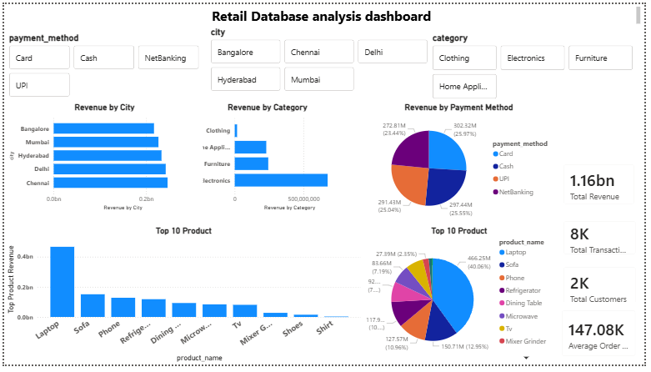
Fig : Analysis Report
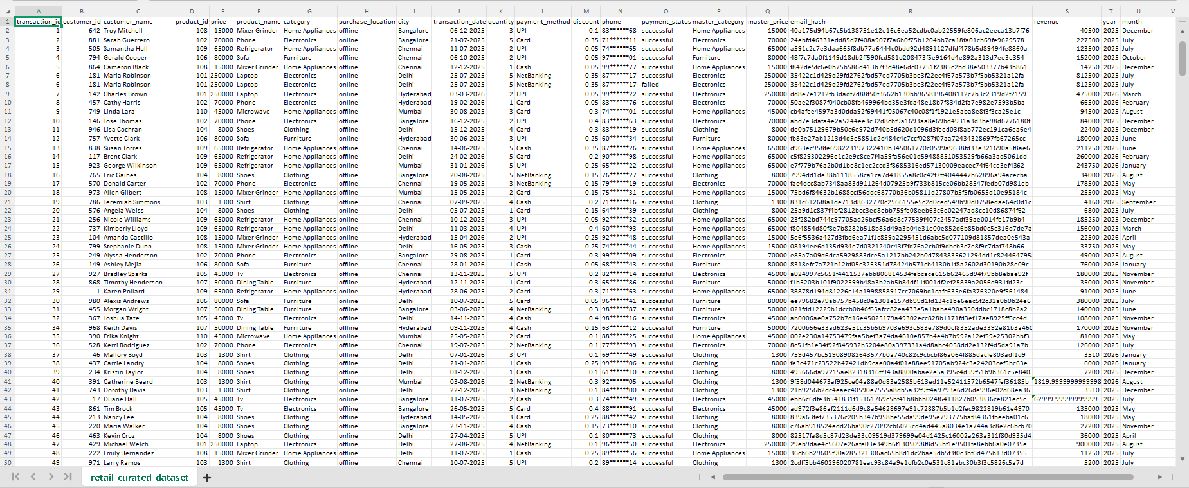
Fig : clean dataset

